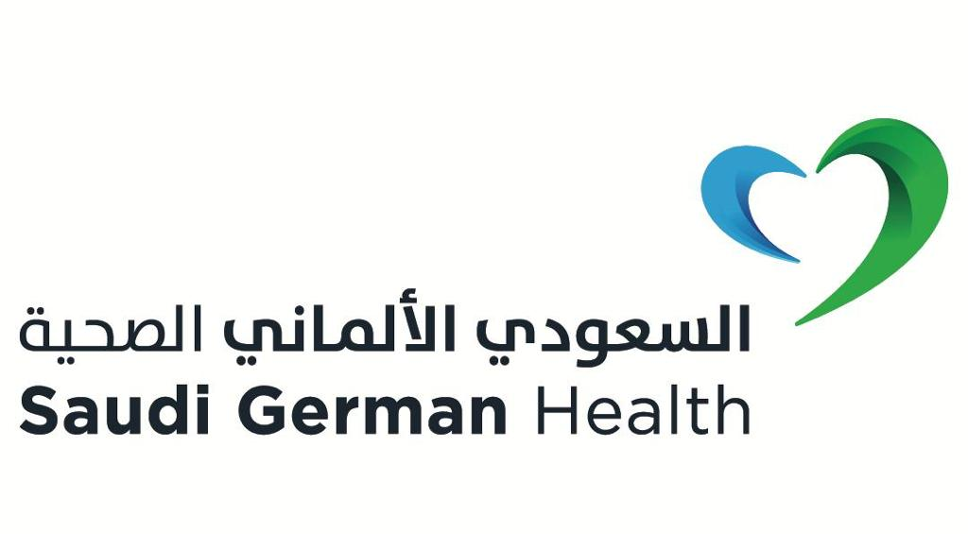

**Saudi German Hospital – Riyadh**

**Academic Affairs Directorate**

**(7th Annual SGH – Riyadh Pediatric**

**& Neonatology International Webinar 2024)**

**(Updates in Pediatrics &Neonatal Care)**

**16th - 18th of November 2024**

**Scientific Program**

**First Day (16 November):**

03:50 – 04:00 pm Opening of the Webinar`

* + - * Opening speech by Dr. Nabil Shehata – Conference Chairman

|  |  |  |  |
| --- | --- | --- | --- |
| **Session I:** |  | | |
| 04:00 – 04:25 pm | Monkey pox an overview | Prof. Dr. Ahmed  El Beleidy | Egypt |
| 04:25 – 04:50 pm | Sepsis: State of art management | Dr. Yasser Kazaz | KSA |
| 04:50 – 05:15 pm | Updates in BPD Management | Dr. Nabil Shehata | Egypt |
| 05:15 – 05:40 pm | New insights in treatment of Hirschsprung disease | Dr. Ahmed Said | Egypt |
| 05:40 – 06:05 pm | Inguinal hernia in premature babies: Early Vs Late repair | Dr. Tariq Altokhais | KSA |
| 06:05 – 06:30 pm | Nec treatment for surgical versus bedside drainage in extremely low birth weight | Dr. Stephanie Polites | Mayo clinic (USA) |
| 06:30 – 06:45 pm | Prayer – Q& A | | |

|  |  |  |  |
| --- | --- | --- | --- |
| **Session II:** |  | | |
| 06:45 – 07:10 pm | Post covid diseases in pediatrics | Prof. Dr. Ahmed  El Beleidy | Egypt |
| 07:10 – 07:35 pm | Pediatrics cardiac emergencies | Dr. Fahd Al habshan | KSA |
| 07:35 – 08:00 pm | PDA in premature baby | Dr. Mohammed Alghamdi | KSA |
| 08:00 – 08:25 pm | Sensory motor integration approach in pediatric rehabilitation | Dr. Nada alkady | Egypt |
| 08:25– 08:50 pm | Acute chest syndrome | Dr. Ali Abdo nasser | KSA |
| 08:50– 09:15 pm | Neurosurgery emergencies in pediatrics | Dr. Safwat Hashem | Egypt |
| 09:15 – 09:30 pm | Q& A | | |

**Second Day (17th of November):**

|  |  |  |  |
| --- | --- | --- | --- |
| **Session I:** |  | | |
| 04:00 – 04:25 pm | Severe asthma in children new era for biologics | Dr. Abdullah Alshamrani | KSA |
| 04:25 – 04:50 pm | Complicated Pneumonia | Dr. Abdullah Alshamrani | KSA |
| 04:50 – 05:15 pm | Early strategy for BPD in extreme preterm infants | Dr. Jane Brumbaugh | Mayo clinic (USA) |
| 05:15 – 05:40 pm | Blueberry Muffin Baby: Think deeply | Dr. Mostafy alsaid | Egypt |
| 05:40 – 06:05 pm | Role of the obstetrician in improving neonatal outcome | Dr. Mohamed Adel | Egypt |
| 06:05 – 06:30 pm | Musculoskeletal infections an update | Dr. Omer Alharbi | KSA |
| 06:30 – 06:45 pm | Prayer – Q& A | | |

|  |  |  |  |
| --- | --- | --- | --- |
| **Session II:** |  | | |
| 06:45 – 07:10 pm | Liver disease Vs liver failure | Dr. Hind Nour | Sudan |
| 07:10 – 07:35 pm | Questioning the immune system: When Doubt is warranted | Dr. Radwa Alkady | Egypt |
| 07:35 – 08:00 pm | Challenges in diagnosing Neonatal anemia | Dr. Raghdaa Ali | Egypt |
| 08:00 – 08:25 pm | Can a pediatrician be an ophthalmologist | Dr. Manar Alnajjar | KSA |
| 08:25– 08:50 pm | Latest updates in ROP pathology and Management | Dr. Manar Alnajjar | KSA |
| 08:50– 09:15 pm | Withdrawal management in neonates | Dr. Nabil Shehata | Egypt |
| 09:15– 09:30 pm | Q& A | | |

**Third Day (18st of Novmber):**

|  |  |  |  |
| --- | --- | --- | --- |
| **Session I:** |  | | |
| 04:00 – 04:25 pm | Management of hypertension in children up-to-date | Dr. Saeed alghwery | KSA |
| 04:25 – 04:50 pm | Necrotizing entero-colitis prevention and Management | Dr. Latifa almahmoudi | KSA |
| 04:50 – 05:15 pm | Polycythemia in newborn | Dr. Haider sumaily | KSA |
| 05:15 – 05:40 pm | Pediatric emergencies | Dr. Nabil badran | Egypt |
| 05:40 – 06:05 pm | Lymphatic disorders in Newborn | Dr. Ramy Mostafa | Egypt |
| 06:05 – 06:30 pm | Approach to neonate with stridor | Dr. Iman Almashharawi | KSA |
| 06:30 – 06:45 pm | Prayer – Q& A | | |

|  |  |  |  |
| --- | --- | --- | --- |
| **Session II:** |  | | |
| 06:45 – 07:10 pm | Interesting case presentations | Dr. Samira Ghallab | Egypt |
| 07:10 – 07:35 pm | Golden hour for neonates | Dr. Ameen almotiri | KSA |
| 07:35 – 08:00 pm | Family counseling for syndromic baby | Dr. Abdullah Alfaifi | KSA |
| 08:00 – 08:25 pm | Golden week for neonates | Dr. Samira Ghallab | Egypt |
| 08:25– 08:50 pm | Ambiguous gentalia: CAH as an example | Dr. Abdulhakim  Alotay | KSA |
| 08:50– 09:15 pm | Approach to a child whit hematuria | Dr. Saeed Alghwery | KSA |
| 09:15 – 09:30 pm | Q& A | | |

***End of the program***